Title (Single Space, Times New Roman 18pt, Bold, centered)
Authors (Times New Roman 12pt, Bold. Centered.1st author is the corresponding author)
(Corresponding author to be mentioned by the footnote 1)

E-mail Address
Affiliation
(Affiliations & E-mail Address, Times New Roman Cantered 10 pt.)

*(Articles must not exceed 2000 words at most)
*(All main headings Times New Roman, 14pt, bold)
*(All Sub headings Times New Roman, 12pt, bold)

Abstract
(maximum 250 words, Times New Roman 12 normal)
* For the body of the manuscript
Please use: Times new Roman 12 normal.
1.5 spaced throughout the article.

Keywords: (Maximum 4 words separated by commas, Times New Roman 12pt normal).
- Introduction
(Times New Roman 12pt normal).
- Experimental details
(Times New Roman 12pt normal).
- Results and Discussion
(Times New Roman 12pt normal).

Example for headings and sub headings if required:

3-Results and Discussion (Times New Roman 14pt bold)
3-1- Tensile Test (Times New Roman 12pt bold)
3-1-1- Strain (Times New Roman 12pt bold)

Table 1: an example. (Times New Roman 12pt Centered.)
 | All table Headings | Times New Roman 12pt bold
Font | Times New Roman | Times New Roman | Times New Roman
Size | 12 | 12 | 12
Style | Normal | Normal | Normal
Spacing | All centered

3-2- Units, terminology and symbols (heading 2, Times New Roman, 12pt)
Acceptable system of units is standard metric (SI). Use consistent spelling in English throughout the paper. Use single quotes and do not use ampersands (&) expect as a part of an official name of an organization or company. Use % and not percent. Keep hyphenation to a minimum. Do not end headings with full stops. Leave one-character space after all punctuation.
3-3- Tables and figures (heading 2, Times New Roman, 12pt.)
Number tables and figures consecutively, e.g. Figure 1, Figure 2; Table 1, Table 2. Use (a), (b) to distinguish between individual subjects in composite figures. Each figure and table must have a caption typed in Times New Roman 11 point normal, justified centered stating with capital letter and ending with full stop. Captions are placed above tables and below figures. Leave one spacing line (12 pt.) between table and/or figure and body text. No spacing line between caption and/or table and figure. Always refer to figures as ‘Figure’ and not Fig.

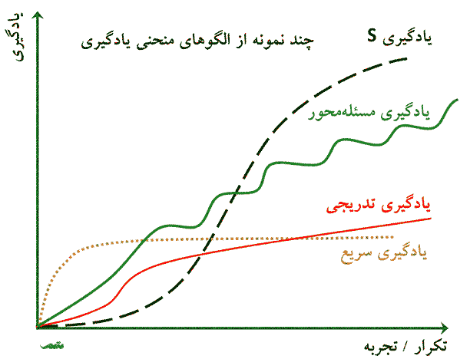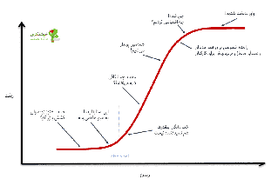
Figure 1. An example. (Times New Roman 12pt., before 0 pt., after 0 pt.)

For text in figures and tables do not use fonts smaller than 12 points font, type must be Times New Roman. Figures and tables that are rotated 90 degrees, have to be read from the right side of the paper. Figures and tables have to be inserted in the text, not at the end of paper. Pictures must be original photographs of good quality and printed with high contrast.
3-3- Mathematical expressions (heading 2, Times New Roman, 12pt,)
Mathematical expressions are justified left and numbered in brackets at the right margin. Make one carriage return before and after the equation, see following example:

3ω y + 9 x²= Sin α (1)
3-4- Lists (Times New Roman, 12pt)
Single space items with no spacing marked either by solid bullets ‘•’ or with an Arabic numeral followed by a full stop, e.g. 1. 2. 3.
- Conclusions
Times New Roman 12 point normal.

Acknowledgements
If any, the name of the person/institution who has supported the work may be cited here (Optional).

References
The references must be numbered chronologically in bold: [1] [2] [3] and cited in the body text using square brackets [1] typed in Times New Roman 12 point normal, line spacing 1.15. Leave one space line between refrences. All references listed must be cited and all cited references must be included in the reference list. The format is shown by the examples below:

[1] A. Gharib and A. Ghaffari,” A New Method for Evaluation of Friction of in Bulk Metal Forming", Journal of Materials processing Technology, 152, 136-142.

[2] R. Salemi, M. Aadelizadeh, “Mechanochemical Carbothermic Reduction of Ilmenite”, 10th Word Conference on Titanium, Homburg-Germany, July 2003, 269-275.

[3] Y. Yassi, Ph. D. Thesis. University of Aston in Birmingham. 2000.

Corresponding author

